|  |
| --- |
| Department of Software Engineering  Mehran University of Engineering and Technology, Jamshoro |

|  |  |  |  |
| --- | --- | --- | --- |
| SWE411 – SOFTWARE DESIGN AND ARCHITECTURE | | | |
| Instructor | Mr. Arsalan Aftab Memon | **Practical/Lab No.** | 14 |
| Date |  | **CLOs** | 3 |
| Signature |  | **Assessment Score** | 0.4 Marks |

|  |  |
| --- | --- |
| Topic |  |
| Objectives | * Procedural design (Decision table) |

|  |
| --- |
| Lab Discussion: Theoretical concepts and Procedural steps |

**Theory:**

**DECISION TABLES**

Decision table provides a handy and compact way to represent complex business logic. In a decision table, business logic is well divided into conditions, actions (decisions) and rules for representing the various components that form the business logic. Decision table is a way to decision making that involves considering a variety of conditions and their interrelationships, particular for complex interrelationships. People use decision table to represent and discover business logic, which ultimately lead to better business.

* **Consists of three parts**
* Condition rows
  + Lists condition relevant to decision
* Action rows
  + Actions that result from a given set of conditions
* Rules
  + Specify which actions are to be followed for a given set of conditions

**Example (Youtube)**

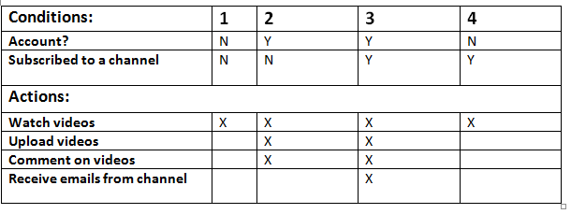

**Another Example**

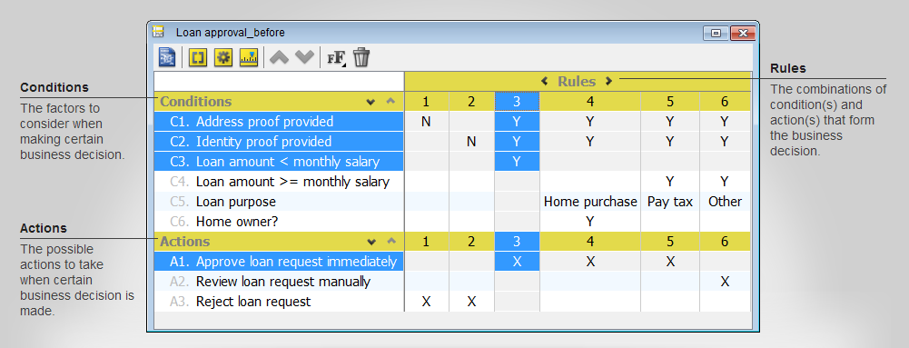

**Why use decision tables?**

* Powerful visualization
  + Compact and structured presentation
* Preventing errors is easier
  + Avoid incompleteness and inconsistency
* Modular knowledge organization
  + Group related rules into single table
  + Combine tables to achieve decision

**TASK:**

Define an application of your choice and make a decision table for that application’s features.